**Hong Kong Baptist University**

**Department of Communication**

**JOUR2076 Data Journalism  
1st Semester 2019-20 (Section 1)**

**Tsang Hoi Yan, Nicole (19221010)**

**Wong Po Yee, Kardia (19203721)**

**Chung Yuk Yu, Tiffany (18204627)**

**Kwong Ho Yin, Kenny (18201806)**

**Hong Kong Families Divided Over Protests**

**1. Background** **1**

**2. First-hand data (questionnaire)** **2**

**3. Second-hand data (research)** **7**

**4. Case study data (interview—young protester moved out and a “red ribbon” mother)** **12**

**5. Case study data(interview—social worker)** **15**

**6. Suggestion** **17**

**7. Reference** **18**

#### **1. Background**

The protest against the extradition bill has lasted for half a year since June, the Hong Kong protests have become symbolized will different color ribbons which represent support on a different side and party. Yellow for the anti-government demonstrators, and blue for those who are showing their support for police and the authorities. With millions marching to protest fighting for freedoms under Beijing’s rule over the last 100 days, yellow ribbon challenge police excessive use of force.

Hong Kong families divided over protests, younger protesters usually think themselves at ideological odds with parents or older relatives, who either support control under authoritarian leaders in Beijing or agree on the police use of force. This leads to a big contradiction between police and protesters and leads to antithetical, especially for the supporter between this two-party.

Accordingly, some of the young protesters cannot bear the argument and pressure between them and their family, they try to move out and find a comfortable space on their own.

In this paper, we are going to point out the problem of Hong Kong families divided over protests, and support the phenomenon with first-hand and second-hand data, also provide case studies and the suggestion on the problem-solving.

#### **2. First-hand data (questionnaire)**

Here is our questionnaire results:

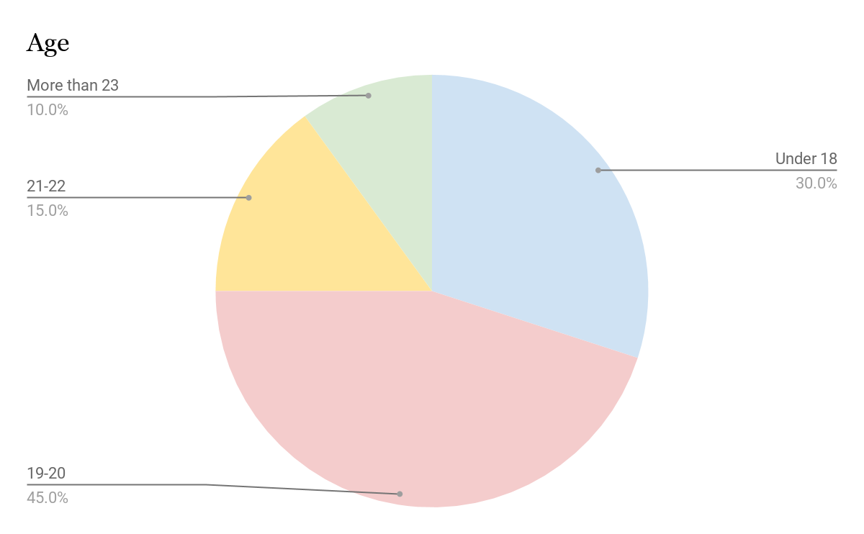

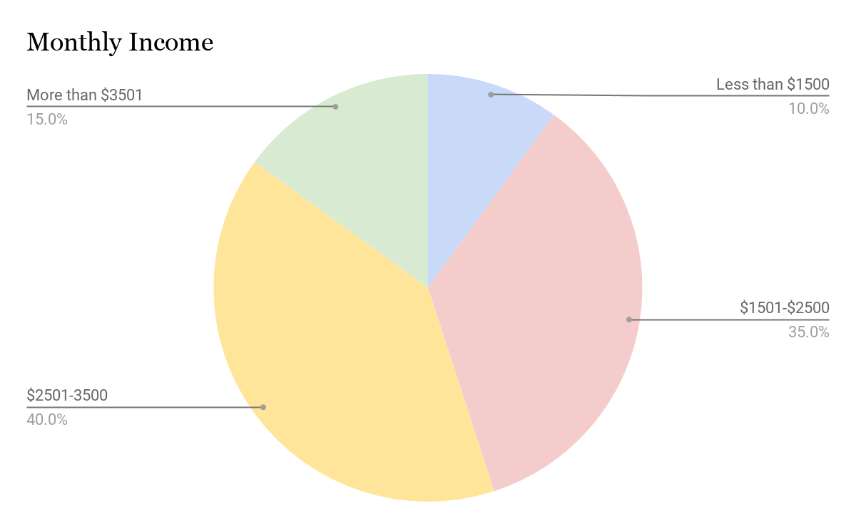

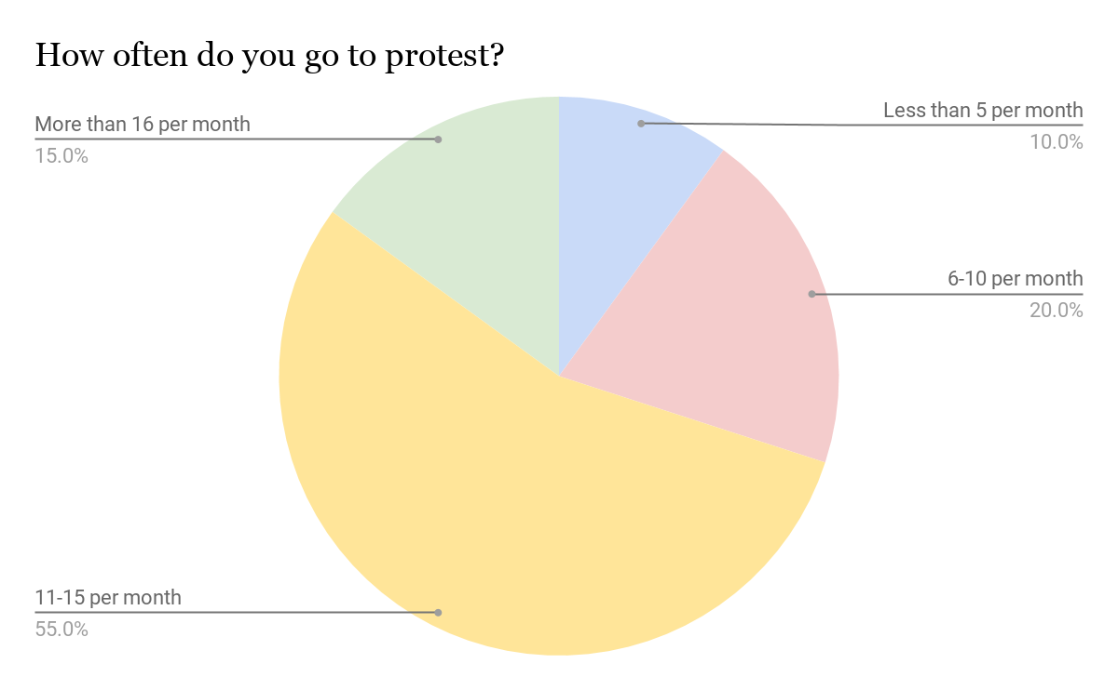

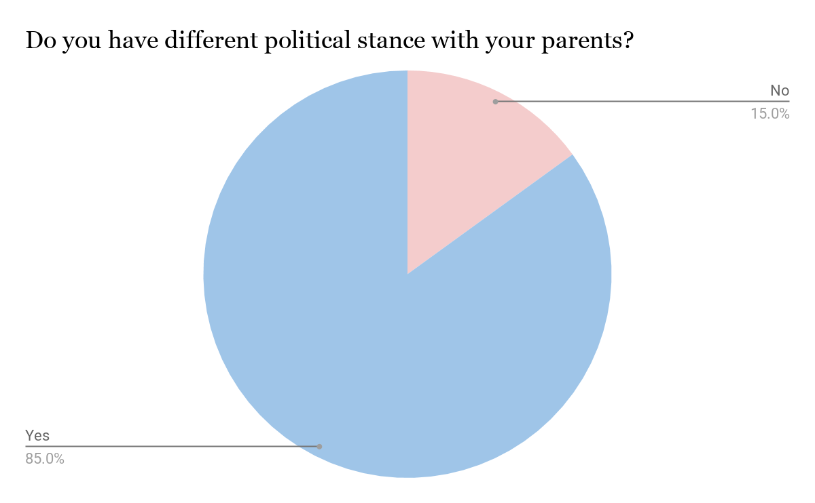

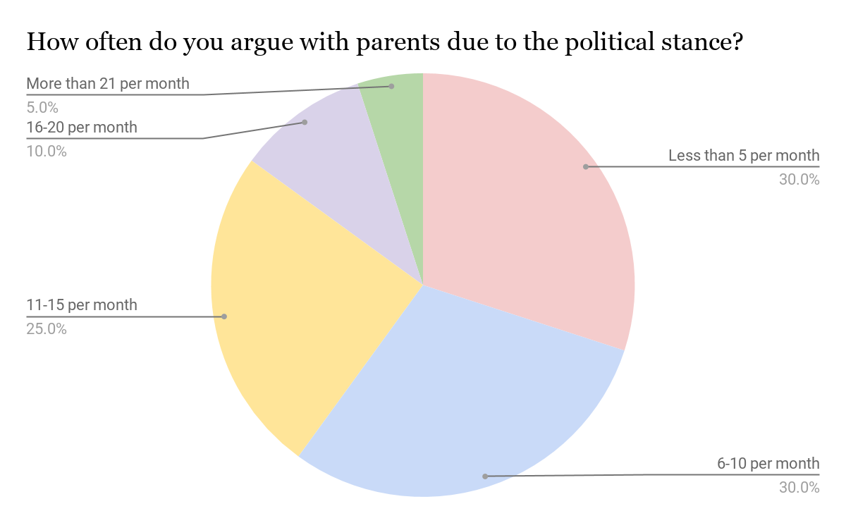

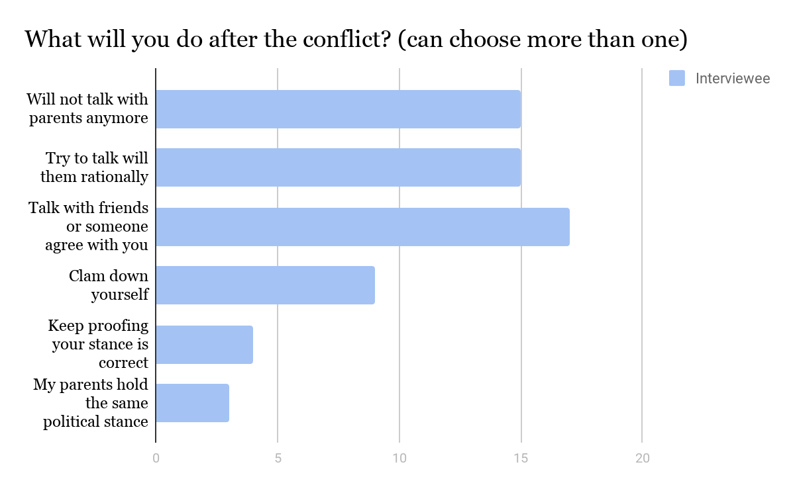

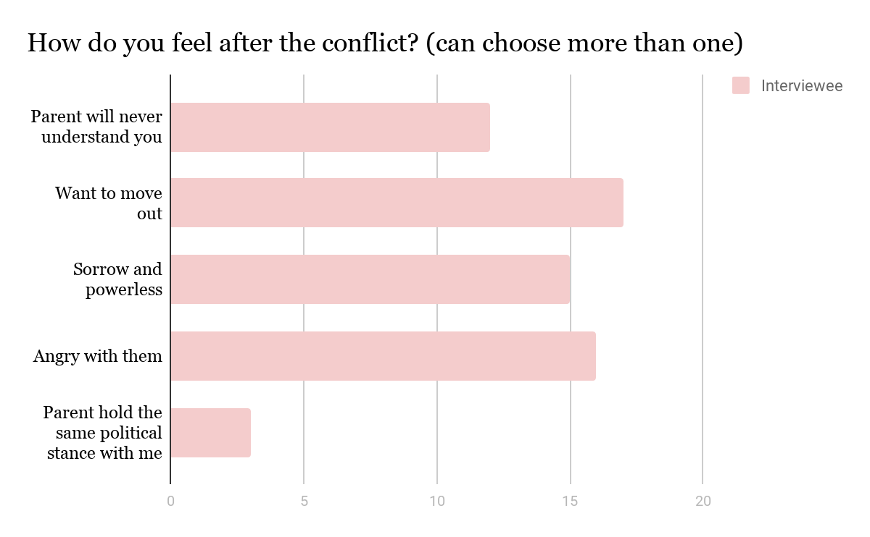

To find out the consequence of this social moment since June. We have set a questionnaire and ask 20 citizens to attempt, there are 7 questions in our questionnaire. 19-20 age group is the majority, which has 9 people. The age group under 18 is the second one, which contains 30%.

Most of them can only gain $2501-$3500 per month because they are still studying in school, they can barely afford by their monthly income. However, those who can barely afford themselves participate in social protest actively.

11-15 times per month, which is a high amount.

Besides, 85% of interviewees are having a different political stance with their parents. Most likely they are in yellow ribbon, which is anti-government, and their parents are in blue who show their support to police and different authorities.

They may argue with each other based on different social situations, most likely 6-10 times per month. Some of them even argue more than 20 times per month.

Among those 20 interviewees, after they have conflicts with their parents, they will talk to their friends, because they know the feeling of what they are facing each other. Second, they will try not to communicate with their parents anymore or talk with them rationally.

The seed of moving out starts to germinate in their minds because they think their parents will never understand them.

After they finished the questionnaire, we have invited one of the interviewees who have moved out from their parent's house for an in-depth interview, the reasons why she starts arguing with each other is the blind support of their parents to the police. They never say anything wrong about Hong Kong Police, even if they saw that violent moment, they will appreciate Hong Kong Police, and blame protesters for setting roadblock or damaging. Her parents don't know what they are fighting for and didn’t accept any explanations or space of communication, since she is unable to bear those opinions of their parents, so she moved out with their low income.

Therefore we have found that once they can’t bear the opinion of another side, they will try to avoid it. Besides, some of the parents don’t understand much about what their children think. It caused some teenagers to run away from home. Some of them may choose to live in university halls or using their savings to rent a house.

#### **3. Second-hand data (research)**

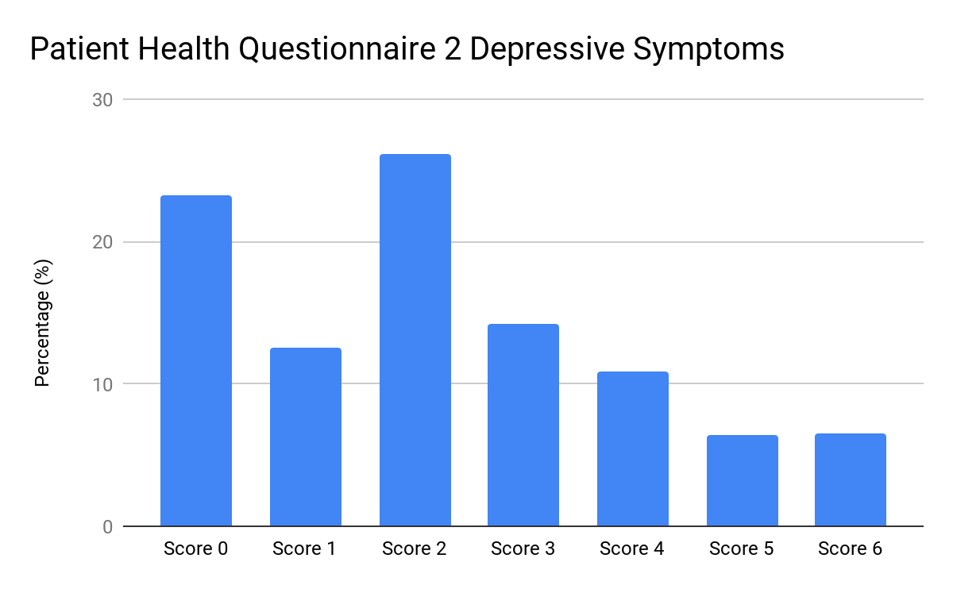

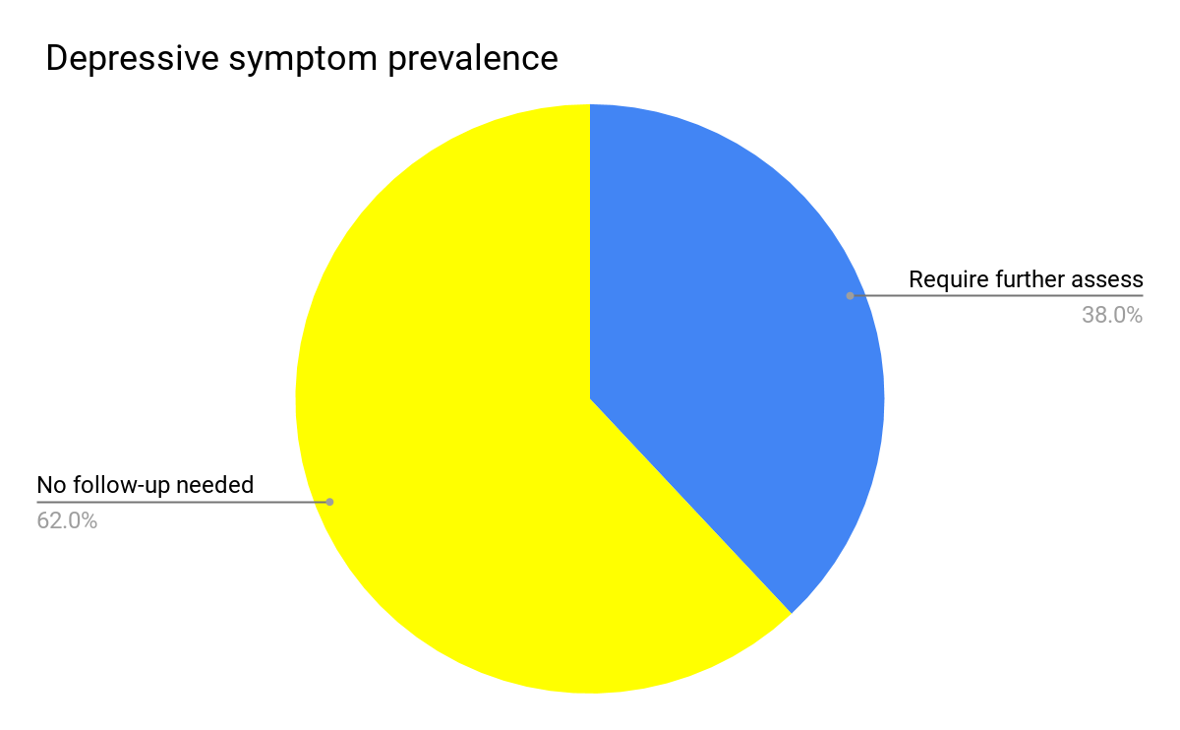

The Motivation and Emotion Laboratory of the Department of Psychology, The Chinese University of Hong Kong (CUHK), has conducted an online survey study titled “Emotional Well-being and Political Engagement” from 18 to 29 September 20191, with regard to the demonstrations associated with the Anti-Extradition Law Amendment Bill movement (Anti-ELAB). The result shows that nearly 40% of the respondents have reportedly experienced depression-related symptoms in the past two weeks. The respondents have polarised emotional reactions towards different social groups. The tendency to dehumanise others is also common.

The research team distributed the online survey link via various means (including Telegram groups, Facebook pages, online news commentaries)during the survey period. A total of 1,937 responses were collected, in which 1,037 (53.5%) of them were valid. The team used Patient Health Questionnaire-2 (PHQ-2) to assess respondents’ psychological well-being. The result shows that 38% of the respondents were troubled by depression-related problems, including “feeling depressed” and “having little interest in doing things”. This figure is much higher than the rate of suspected depression (9.1%) cases in Hong Kong reported by another similar survey in July 2019.

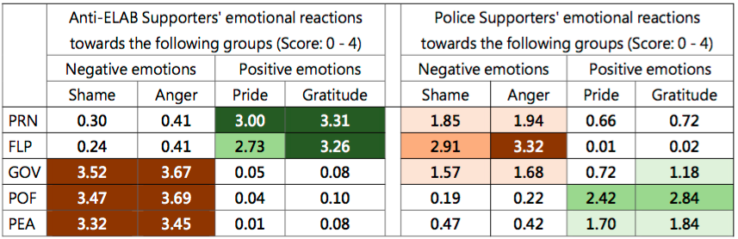

Note:

Anti-ELAB Supporters’ and Police Supporters’ average emotional reactions towards different social groups. Darker cells represent more intense emotional reactions.

Emotional intensity scale: 0 = Not at all, 1 = A bit, 2 = Moderately, 3 = Strongly, 4 = Very strongly.

PRN = “Peaceful, rational, and non-violent protests” refers to people who insist on using peaceful, rational, and non-violent means (e.g., parade and assembly, posting slogans) to voice their opinions in anti-ELAB-related demonstrations.

FLP = “Frontline protestors” refers to people who use comparatively radical means (e.g., setting up roadblocks, physically clashing with law enforcement officers) to voice their opinions in anti-ELAB-related demonstrations.

GOV = “Hong Kong Government” refers to Hong Kong government principal officials, such as Chief Executive, Chief Secretaries, and leaders of Bureaux.

POF = “Hong Kong Police Force” (HKPF) refers to all law enforcement officers in HKPF, such as riot police, police public relations branch, and tactical squad officers.

PEA = “Pro-establishment Activists” refers to people who are discontented with demonstrations related to the anti-ELAB movement and perform counter-protest behaviors (e.g., attending assemblies in support of the police, deterring protestors from posting slogans).

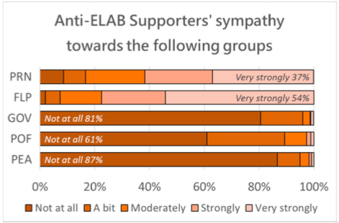

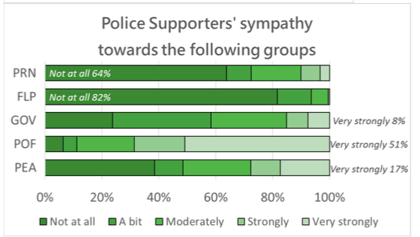

**Polarised Emotional Reactions Among the Respondents**

The research also shows that the respondents had polarised emotional reactions towards different social groups. On average, respondents who supported Anti-ELAB demonstrations and opposed the police’s law enforcement behaviour (anti-ELAB supporters) held moderate to strong positive emotions (pride, gratitude) towards “peaceful, rational, and non-violent” (PRN) and “frontline” protestors3 but strong negative emotions (shame, anger) towards the Hong Kong Police Force (HKPF), Hong Kong Government, and pro-establishment activists. On the other hand, respondents who supported the police’s law enforcement behaviour and opposed anti-ELAB demonstrations (police supporters) held moderate to strong negative emotions towards “frontline” protestors but moderate to strong positive emotions towards the HKPF. Regardless of political stances, the stronger the emotional reactions the respondent had, the more political activities (e.g., petition, parade or assembly) the respondent engaged in, and the more psychological health problems the respondent experienced.

The phenomenon of emotional polarisation can also be reflected in how much sympathy the respondents had towards different social groups. Over 60% of anti-ELAB supporters reported having “no sympathy at all” towards the HKPF, Hong Kong Government, and pro-establishment activists. Meanwhile, over 60% of police supporters reported having “no sympathy at all” towards “PRN” and “frontline” protestors. This study has also investigated the phenomenon of respondents dehumanising different social groups. For the question “Do you think (social groups) should be treated as animals (e.g. cockroaches, dogs) (from 0 - 10),” only 21.6% of respondents answered “absolutely should not” for all social groups. In other words, nearly 80% of respondents have some degree of dehumanisation tendency towards at least one of the social groups.

#### **4. Case study data (interview—young protester moved out and a “red ribbon” mother)**

We have done an interview with a girl who moved out because of his father’s stance and a “red ribbon” mother who has two daughters but moved out to the university hall after an argument with her husband.

Jasmine, a 21 years old university student, she describes herself as a moderate—not one on the frontlines. For over three months, she keeps quarrel with her parents and lied to her father about joining the protests — until she can’t bear it and had to move out. Her father was a policeman since she was small, and she describes her father as a “red ribbon” which means his father supports the government and agree with his colleague’s use of force because he usually describes young protester as “rioters”.

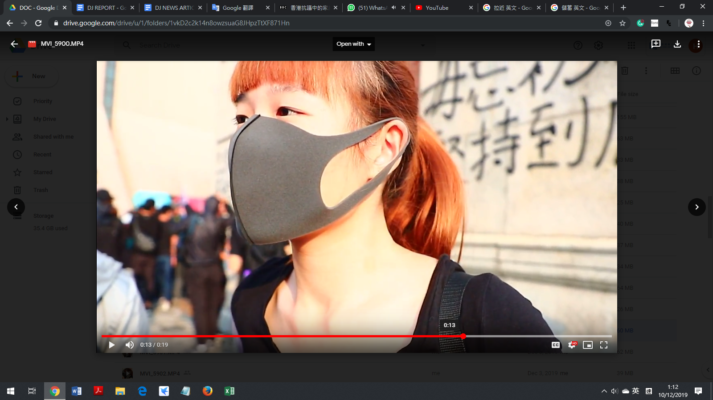

Jasmine said that she always tries to explain the movement’s goals of a more democratic Hong Kong to him rationally and tell him why she will join the protest. But her father won’t stand by her and only trusts what his colleague said. Their arguments fell on deaf ears with her father, Jasmine finally decided to rent a house herself in order to have a space to calm. She used her part-time salary and money saving to rent a house and live herself.

After moving out, she felt the stress is relieved because she does not have to hide her real through anymore and feel free to speak any time, also she can avoid to listen her parents criticism the young protesters. However, she cannot bear the rent because she is still a university student, and move back home helplessly. But after that, she realized it is helpless to tell her parents “the truth” about the movement, she tries to avoid talking with them and usually back to her room when she came back home.

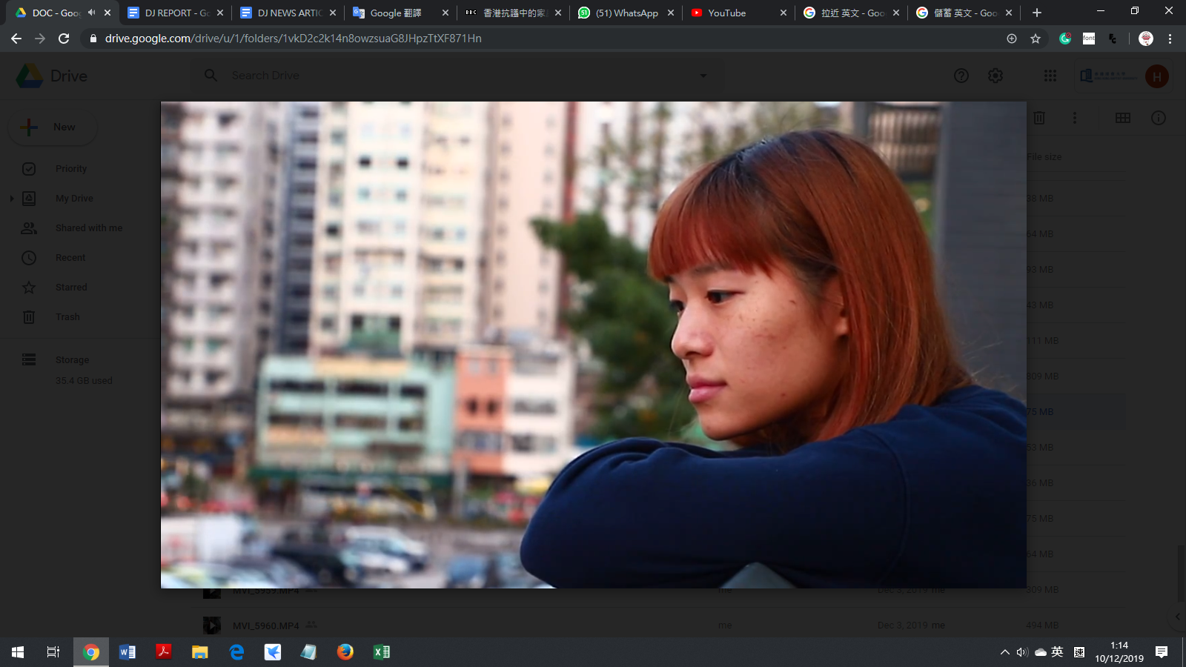

We also do an interview with Wong, who was a two daughters’ mother, both of the daughters were “yellow ribbon” and go to protest frequently. Her two daughters Miki and Bobo quarreled with father because of political opinions in mid-August, they run away from home and both of them live in university halls now.

Every time there was a protest, Wong was afraid her daughters will be arrested and felt powerless that her daughters moved out. She mentioned that her husband was a pro-Beijing supporter, and he thought it was great to under control by authority of the Beijing government. Therefore, everytime when he discussing the political issue with his daughters, he will say that if they don't recognize themselves as a Chinese, don't come home anymore.

Wong describes herself doesn’t care about politics and she only hopes her children have a stable job and form a family. She never imagined that the anti-extradition bill protest will make such changes to the relationship between her and her daughters. She said at the very beginning, she thought the protesters were brainwashed and there was an involvement of foreign forces even tell her daughters that do not do illegal things because of money. But her daughter felt very angry because they didn't expect Wong will see them like this way.

Wong change her mind because in 13 Nov, many protesters gather in Sha Tin, she knows that the demonstrators were near her house, think that her daughters will also be there, so she go there and looking for children on the street. However, she saw hundreds of the neighborhood wearing slippers surrounded and cursed the police and realized that it wasn't just the young people hated the police but also some neighborhood on her age. She saw how the riot police yelled at her and other neighbors, and she can smell a tear gas came out from the window. After this day, she thinks that her children did not collect any money to do these things. Because she believes no one would like to smell tear gas like this and used to think that the police enforced the law to arrest violent protesters, but at the scene, the police use of force sometimes is excessive. "

Therefore, she decided to find her daughters for conversation. Although she doesn't agree with protester using illegal methods to fight for some demand, and think that the police must stop them. But she doesn't think keep arresting the protester is helpful for solving the problem. But at least she tried to talk to her daughters rationally, although this cannot solve the contradiction, she tried to narrow the gap between them.

After the case study, we can find that most young protesters do not know how to communicate or be tolerant to the opposite side, especially their parents, also some of the parents really don’t understand much about what their children think and what they are trying to fight for, but they usually say something impulsively which will hurt their relationship or it may cause some of the teenage choose to escape and run away from home in order to prevent conflict and avoid communicating with parents about the political topic again. Some of them may choose to live in university halls and some of them were using their savings to rent a house.

#### **5. Case study data(interview—social worker)**

**500 emotional support cases since July, more than half of young people feel desperate**

The collapse of the public's mental health has also spawned various emotional support and search and rescue teams. Two representatives of the civilian support network said that volunteers and voluntary social workers with search and rescue experience were organized to provide emotional support and assistance to the public in search and rescue.

They said that about 500 cases have been processed since early July, of which 30% have an immediate crisis, and many people will leave testaments to complain of social injustice; 5 adults have thought of despair.

The age group of the cases was mainly young people between the ages of 11 and 24. Many of them tried suicide more than once, and some even had 4 to 5 times within 4 months. The main cause of many people's death is that it is difficult to see Hong Kong's future, and they hope to "match each other with death."

There are also many people who disagree with their family members and run away from home or are driven away from their families.

A social worker, Lau Ka Tung, who went to the frontline to persuade both police and protesters to keep calm frequently. “I have received a number of cases about teenagers moved out from home within these few months, different political stance with their parents is the biggest reason.” Lau said.

“It seems it is an irreversible situation for everyone insists on their own opinion in this protest, they are not willing to make concessions. In consequence, they lost the ability to communicate or be tolerant to the opposite side.” Lau added.

When he received cases about teenagers moved out from home, the first important thing to do is crisis intervention —— to help the patient seeking an accommodation to solve the crisis, after that is to do psychological counseling, to encourage the child to have a conversation with their parents so as to solve the core problem.

#### **6. Suggestion**

American scholars Kenneth Thomas and Ralph Kilmann (1974) divide the methods for dealing with conflicts or differences of opinion into five categories and level— ***competition, accommodation, avoidance, compromise, and cooperation.***

The ***competition*** which means that you think that you must be right and the other must be wrong, and very concerned about your own opinions, want to "win" anyway, even if the relationship with the family will be broken. ***Accommodate*** means that you may not agree with others, but you choose to tolerate for kindness, and you think the relationship between you and your family is more important, so you will give up to talk about your true views and even pretend you agree with them. ***Avoidance*** means both sides felt it was useless to talk more, or will tend to avoid talking about political topics.

The above three approaches have their own "benefits", competition helps to "win"; accommodating does not harm to the relationship; avoiding at least can avoid a quarrel. However, these kinds of approaches have their own "bad points", especially the competition "wins" the quarrel but "loses" the relationship. Therefore, there will have a better approach which is ***Compromise and Cooperation.***

Kenneth Thomas and Ralph Kilmann (1974) mentioned that ***Compromise*** is a moderate mode that emphasis on expressing yourself and maintaining the relationships, you and your family can express own views under two sides agreed, such as both agreed that both of you must not attack anyone when expressing, as a listener but must tolerate and respect although you do not agree with each other.

The last approach is ***Cooperation*** which is a high emphasis on expressing yourself and maintaining relationships. Cooperation and compromise are similar, but cooperation requires both of you to show empathy and try to find common ground. In the process of cooperation, family members can pay special attention to the other’s views and positions, express their view, and try to understand the other’s, instead of persuading or attacking the other party’s view.

Family relationships are very valuable, but it is not easy to repair after broken. Although family members have a different political stance, they should not be used as a trigger for affecting family relationships.

Although people inevitably hold different political opinions, there will be a better way to handle the relationship. Social worker, Lau Ka Tung also suggested that, rather than quarrel, talk to each other rationally and try to be a good listener, showing empathy and understanding, which can help parents to keep a better relationship with their children and avoid they run away from home because the argument. Parents also can show their care to their children, use a soft tone to communicate with them rather than use a admonish and “parents tone” to judge them.

#### **7. Reference**

Thomas, K. W., and Kilmann, R. H. The Thomas-Kilmann Conflict Mode Instrument (Mountain View, CA: CPP, Inc., 1974)

民間記者會民調：抗爭者現創傷壓力徵狀 轟元兇為政府及警暴（2019年11月2日）

<https://www.inmediahk.net/node/1068333>

中大心理學系網上問卷調查顯示 近四成市民於反修例事件的社會氣氛下 出現與抑鬱症相關的症狀（2019年10月21日）

反修例心理輔導 三成求助醫護憂安危 醫管局：同事壓力大 求助增15%（2019年11月4日）  
<https://news.mingpao.com/pns/%E8%A6%81%E8%81%9E/article/20191104/s00001/1572805296191/%E5%8F%8D%E4%BF%AE%E4%BE%8B%E5%BF%83%E7%90%86%E8%BC%94%E5%B0%8E-%E4%B8%89%E6%88%90%E6%B1%82%E5%8A%A9%E9%86%AB%E8%AD%B7%E6%86%82%E5%AE%89%E5%8D%B1-%E9%86%AB%E7%AE%A1%E5%B1%80-%E5%90%8C%E4%BA%8B%E5%A3%93%E5%8A%9B%E5%A4%A7-%E6%B1%82%E5%8A%A9%E5%A2%9E15>